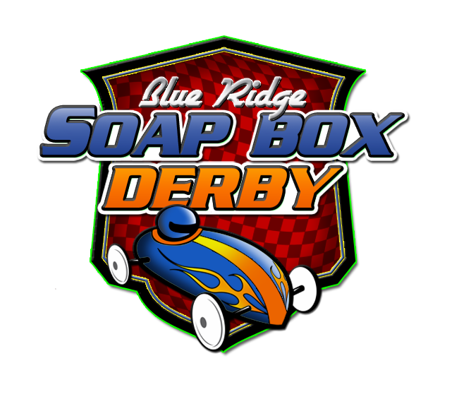
The Blue Ridge Soap Box Derby
Po Box 1924, Blue Ridge, GA 30513
www.facebook.com/TheBlueRidgeSoapBoxDerby www.theblueridgesoapboxderby.org
2022 Spring Derby Registration Form

Driver Information Age: ___________
Name: |  | Derby Car Identification:
DOB: |  | Official Car Registration #:
Address: |  | Phone:
City/State/Zip Code: | T-Shirt Size (specify Youth/Adult Size):
*Email Address: T-shirt guaranteed only for drivers registered by April 15, 2022
*Drivers 18 years or older; otherwise use parent email below.
Emergency Contact Name/Phone Number (Other than a parent):
I, ___________________________, driver of a Soap Box Derby car entered in the Blue Ridge Soap Box Derby
certify that my car follows all current guidelines, event rules, and I will perform a safety inspection prior to each race/heat. It is my responsibility to read/adhere to all event rules and directions of staff.
Driver Signature: ___________________________________ Date: ____________________________
_____

Select Your Race Category
Race Category | Registration Fee
Category 1 Classic (Age 7-12) | $20
Category 2 Classic (Age 13+) | $20
Category 3 Outlaw (Age 7+) | $20

Parent/Guardian Information (for Drivers under 18 years old)
Parent/Guardian Name: | Phone Number:
Parent/Guardian Email Address:

I, __________________________________ (parent/guardian), hereby certify for myself, and for my son/daughter/ward, ___________________________, shown as the “Driver” above, entrant in The Blue Ridge Soap Box Derby, that we have read the above statements, completed the information, and know the facts stated therein to be true and correct (as of April 30, 2022).
I hereby grant permission for my son/daughter/ward to enter The Blue Ridge Soap Box Derby. Further, I understand and agree that, as a prerequisite to competing in The Blue Ridge Soap Box Derby, that my son/daughter/ward, together with his/her car, shall have undergone a safety inspection of their car to ensure all pre-race procedures have been performed and (if required) passed an inspection by an official of The Blue Ridge Soap Box Derby (and, if required, any time a derby official deems it necessary for fairness and compliance). I further understand and agree that such inspection shall be conducted using the manner and methods deemed appropriate by The Blue Ridge Soap Box Derby, in its sole discretion, to determine compliance with its rules, spirit and specifications applicable to that division and that the decisions of The Blue Ridge Soap Box Derby and its officials regarding qualification, disqualification and compliance with the rules, spirit and specification applicable to that division shall be final and binding upon me, my son/daughter/ward and all other parties.
Finally, I, as such parent or guardian, in consideration of the benefits received as a result of the participation herein, and for the mutual benefits received by myself and my child and the other participants herein, hereby waive and release any and all claims, rights, causes of action, demands or otherwise, whether for personal injuries, property damage, or any other loss, damages or expenses which I, as a parent/guardian, and/or my son/daughter/ward may have against The Blue Ridge Soap Box Derby, it’s host, the Fannin County School System, and/or its sponsors, agents, employees, full or part-time, or associates of any status whatsoever, arising from or in any manner related to my son's, daughter's or ward's participation in The Blue Ridge Soap Box Derby and/or any activities incidental or related thereto and thus assume all risks inherent or present in participation. I intend the foregoing release to also extend to non-Driver minors who are present and, in my charge, and care. (Sign on next page.)

Parent/Guardian Signature: ____________________________________________ Date: _____________

The Blue Ridge Soap Box Derby – Parents Code of Conduct

As a parent, you play a special role in contributing to the needs and development of youngsters. Through your encouragement and good example, you can help assure that all participants learn good sportsmanship and self-discipline. In The Blue Ridge Soap Box Derby, young people learn to work together, to enjoy winning and deal appropriately with defeat – all while becoming physically fit and healthy. Best of all, they have fun.

Support your child - Supporting your child by giving encouragement and showing interest in their activity is very important. Help your child work toward skill improvement and good sportsmanship in every race. Teach your child that hard work and honesty are important factors that lead to victory.

Always be positive - Parents serve as role models for their children. Become aware of this and work to be a positive role model. Applaud good races by your child and of others. Support all efforts to remove verbal and physical abuse from youth sports activities.

Remember that your child wants to have fun - Remember that your child is the one driving the derby car, not you. It’s very important to let children establish their own goals – to race for themselves. Take care not to impose your own standards and goals on them. Don’t put too heavy a burden on your child to win races. Surveys reveal that 72% of children would rather race in a losing car than watch from the sidelines. Children race for the fun of racing.

Reinforce Positive behavior - Positive reinforcement is the best way to help your child achieve their goals and their natural fear of failure. Nobody likes to make mistakes. If your child does make one, remember its all part of learning, so encourage your child’s efforts and point out the good things your child accomplished.

Don’t be a sideline coach or official - Coaches and officials are usually parents just like you. They volunteer time to help make your child’s experience a positive one. They need your support too. That means refraining from coaching or officiating from the sidelines (this means you MUST stay off the track and out of the recovery and/or staging area for the safety of all participants!). As a volunteer organization, there’s usually always an opportunity for you to take your interest in coaching or officiating to the next level and become one yourself. Please contact an official to become a volunteer or staff member.

Parents Pledge

- I shall set an example for sportsmanship for my child to follow. I shall emphasize team play to my child. I shall show by example respect for officials, opposing drivers and other spectators. I shall not be a “sideline coach”. I shall remember that not everyone can play at one time. I shall not be critical unless I’m willing to work to correct the problem. I shall attend my child’s event because, it is important to them, they are not young forever. I shall be supportive when my child is successful or when struggling for success. I will review all event rules and procedures with my child and ensure they know how to “drive” their car safely and respectfully. I shall be positive and supportive whether my child wins or loses. I shall remember that all event staff and its officials are volunteers. I shall volunteer whenever possible. I shall remember that the race is for the drivers and to enjoy it myself as a spectator.

Remember: Good behavior doesn’t cost anything!!! However, it does allow the drivers and all parents enjoy a race between heats just for the fun of it.

While on Fannin County School Property, my children and I, will: Use crossways when crossing roadways. Always be alert for traffic. Not use profanity. Not play in the parking lots at any time. No horseplay in walkways and “car pits” at any time. Not climb fences. Observe ALL posted signs: Racers and spectators should be always alert for moving derby cars. During races, remain in the designated spectator areas. Help clean up trash in the car pits, spectator areas and parking lot after the race. There is NO SMOKING/TOBACCO/VAPING anywhere on Fannin County School property. Please refrain from this during any of our events. If you must smoke, you need to go to your vehicle.

Parent/Guardian Signature Child/Driver’s Name Date

Send Completed Form & Fee to: The Blue Ridge Soap Box Derby, P.O. Box 1924 Blue Ridge, GA 30513 or delivered to Town & Country Furniture or The News Observer; You may also scan and email signed registration form to: brsoapboxderby@gmail.com Registration Forms are DUE by April 15, 2022. (Registration $ must be paid prior to April 15th, 2022.) Late entries will NOT be accepted!

